**DAILY ONLINE ACTIVITIES SUMMARY**

|  |  |  |  |  |  |  |  |  |
| --- | --- | --- | --- | --- | --- | --- | --- | --- |
| **Date:** | **23/05/2020** | | | | | **Name:** | **Lavanya D M** | |
| **Sem & Sec** | **4th & ‘A’** | | | | | **USN:** | **4al18cs041** | |
| **Online Test Summary** | | | | | | | | |
| **Subject** | | **Data Communication** | | | | | | |
| **Max. Marks** | | **30** | | **Score** | | | **25** | |
| **Certification Course Summary** | | | | | | | | |
| **Course** | **Git tutorial for beginer** | | | | | | | |
| **Certificate Provider** | | | **Bitdegree** | | **Duration** | | | **2days** |
| **Coding Challenges** | | | | | | | | |
| **Problem Statement:1)**Write a C Program to generate first N Triangular Numbers (Where N is Read from the Key board). 2)java program to print **Floyd's triangle** | | | | | | | | |
| **Status:complied** | | | | | | | | |
| **Uploaded the report in Github** | | | | | **yes** | | | |
| **If yes Repository name** | | | | | <https://github.com/lavanyamurthi/lockdown-coding/blob/master/triangular%20number.c>  <https://github.com/lavanyamurthi/lockdown-coding/blob/master/Floyd's%20triangle.java> | | | |
| **Uploaded the report in slack** | | | | | **yes** | | | |

Online Test Details: (Attach the snapshot and briefly write the report for the same)

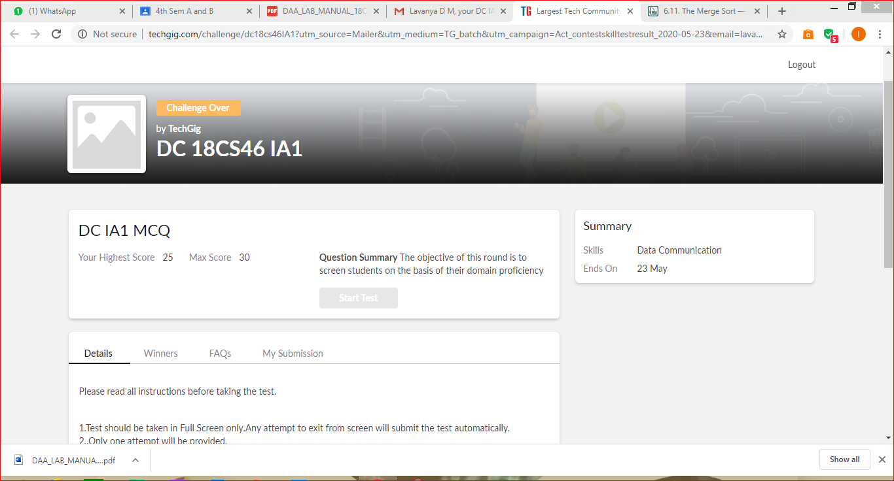

Certification Course Details: (Attach the snapshot and briefly write the report for the same)

<https://github.com/lavanyamurthi/lockdown-certificate/blob/master/cert23may.PNG> <- this the GitHub repository link

In this certificate course I’m learning the Git version, why only git what are the operation is going to done here and so on..

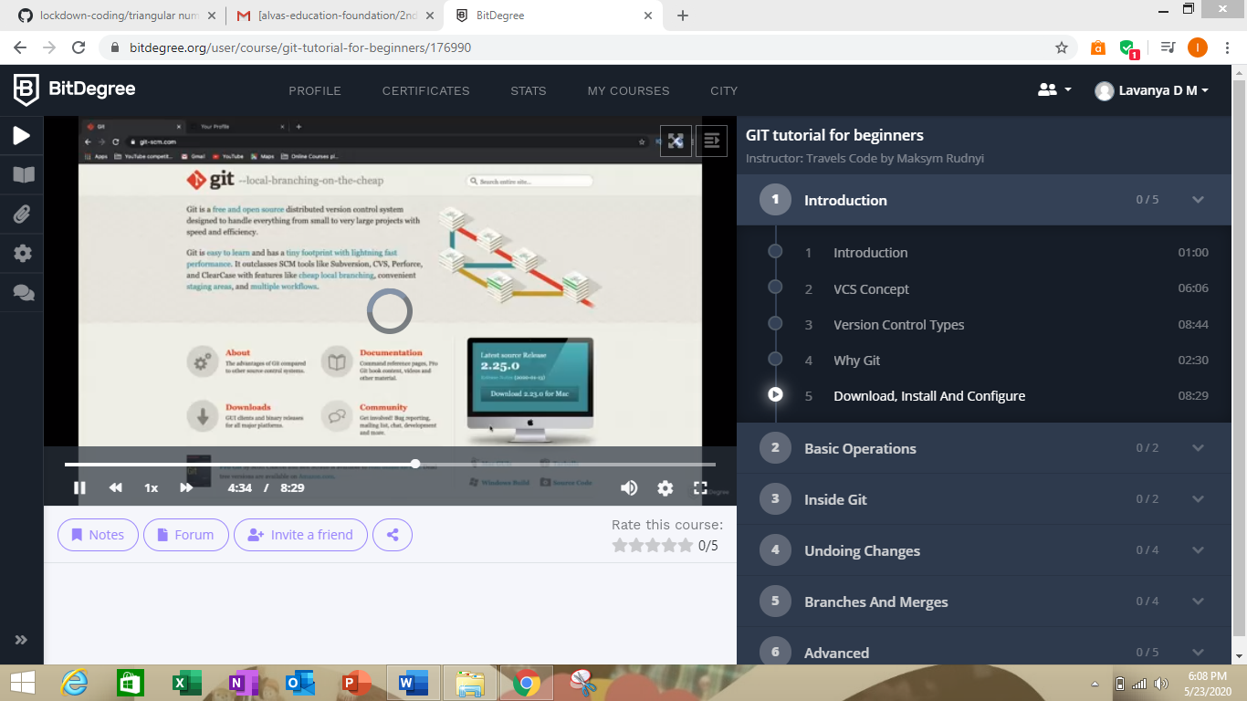

Coding Challenges Details: (Attach the snapshot and briefly write the report for the same)

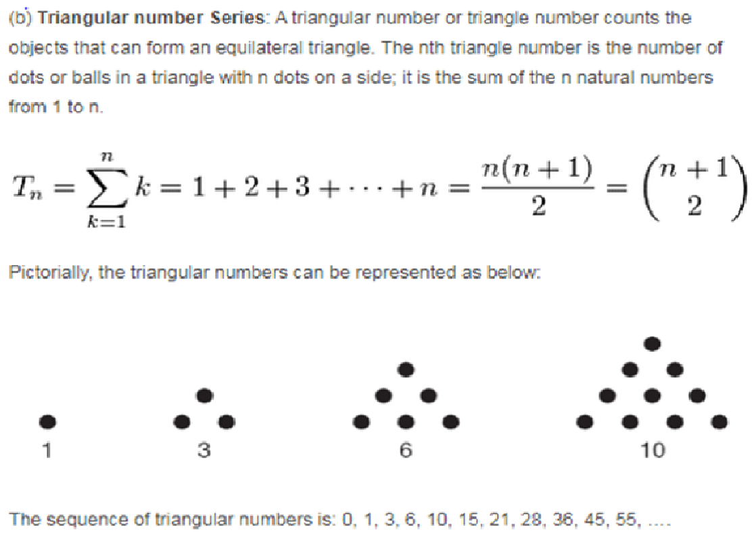

Here is the GitHub repository link of code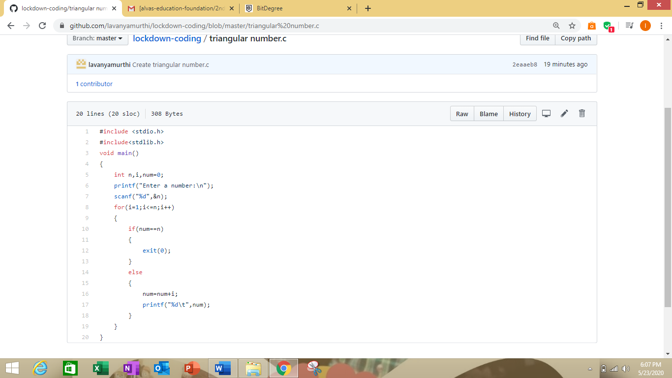e

<https://github.com/lavanyamurthi/lockdown-coding/blob/master/triangular%20number.c>

**2)Java program to print Floyd’s triangle**

<https://github.com/lavanyamurthi/lockdown-coding/blob/master/Floyd's%20triangle.java>

